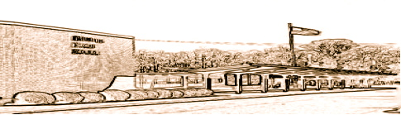
TERRILL MIDDLE SCHOOL
1301 Terrill Road
Scotch Plains, NJ 07076

PHONE: (908) 322-5215 FAX: (908) 322-6813

Dr. Kevin Holloway Mr. Ralph Gerace
Principal Assistant Principal

Dear TMS Families,

Our lawn sign is ready to post your message.

Please complete this form to have a message posted on the Terrill lawn sign. We will do our best to display your message for your requested dates(s). For individual requests, we will only post birthday messages.
Because the school, district, and local government agencies' messages have priority, your message may be delayed or canceled. (*If your message is canceled, as a result of one of the above groups needing access to the sign board, your message fee will be refunded.) All messages are subject to review and approval before it will be posted.
The daily rental hours are 7:30 A.M. to 10 P.M.
Rental of the sign board is available to Terrill families, the TMS PTA, and organizations renting the TMS facility.
Fees:
Terrill families: $30.00 per day (3 lines)
TMS Facility Renters: $50.00 per day (3 lines)
Payments from TMS families must be submitted by check payable to Terrill Middle School and given to the main office. Payments from organizations renting our facility must submit their payment via check, made payable to Terrill Middle School.

Payments and messages must be received at least 2 weeks prior to the requested message posting date. We will not post messages received outside of this timeline. All proceeds will support the 8th Grade end of year trip.

Sincerely,

TMS

